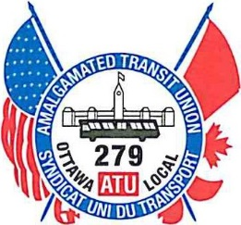

AMALGAMATED TRANSIT UNION LOCAL 279
2212 GLADWIN CRESCENT, UNIT C9, OTTAWA, ONTARIO K1B 5N1 (613) 738-3177 FAX (613) 526-1696

ROYAL CANADIAN MINT

SPECIAL MEETING

NOTICE

There will be a Special Meeting for the Membership of the Royal Canadian Mint with the time and location noted below.

The purpose of this meeting will be to present the Members with the tentative Contract Agreement.

DATE: | Wednesday, January 17, 2024
TIME: | 9:00 A.M. AND 6:00 P.M.
LOCATION: | ATU LOCAL 279 UNION HALL  2212 GLADWIN CRESCENT, UNIT C-9 OTTAWA, ONTARIO, K1B 5N1

We hope that you all can make it to this meeting.

Clint Crabtree
President/Business Agent

